|  |
| --- |
| **BOARD OF MANAGEMENT** |
| Percentage of Programmes where syllabus revision was carried out during the last five years |

|  |
| --- |
| Document Title |
| Minutes of Board of Management indicating the revision of syllabus & regulations and introduction of new programmes during the last five years |





**REGISTRAR**

**SECRETARY -BOARD OF MANAGEMENT**



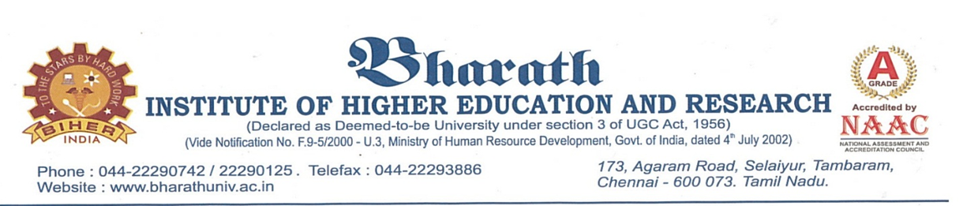This is to certify that the following documents contain Minutes of Board of Management meetings along with agenda items and other activities performed during the last five years.

|  |  |  |
| --- | --- | --- |
| **CONTENTS** | | |
| SI.NO | **Particulars** | **Board of Management Meeting No** |
| 1 | [Board of Management Minutes _30.01.2018](http://demo.bharathuniv.ac.in/NAAC2023/BOM/57.pdf) | 57 |
| 2 | [Board of Management Minutes _16.04.2018](http://demo.bharathuniv.ac.in/NAAC2023/BOM/58.pdf) | 58 |
| 3 | [Board of Management Minutes _24.07.2018](http://demo.bharathuniv.ac.in/NAAC2023/BOM/59.pdf) | 59 |
| 4 | [Board of Management Minutes _29.10.2018](http://demo.bharathuniv.ac.in/NAAC2023/BOM/60.pdf) | 60 |
| 5 | [Board of Management Minutes _28.01.2019](http://demo.bharathuniv.ac.in/NAAC2023/BOM/61.pdf) | 61 |
| 6 | [Board of Management Minutes _19.04.2019](http://demo.bharathuniv.ac.in/NAAC2023/BOM/62.pdf) | 62 |
| 7 | [Board of Management Minutes _17.07.2019](http://demo.bharathuniv.ac.in/NAAC2023/BOM/63.pdf) | 63 |
| 8 | [Board of Management Minutes _28.10.2019](http://demo.bharathuniv.ac.in/NAAC2023/BOM/64.pdf) | 64 |
| 9 | [Board of Management Minutes _20.02.2020](http://demo.bharathuniv.ac.in/NAAC2023/BOM/65.pdf) | 65 |
| 10 | [Board of Management Minutes _20.04.2020](http://demo.bharathuniv.ac.in/NAAC2023/BOM/66.pdf) | 66 |
| 11 | [Board of Management Minutes _13.07.2020](http://demo.bharathuniv.ac.in/NAAC2023/BOM/67.pdf) | 67 |
| 12 | [Board of Management Minutes _20.10.2020](http://demo.bharathuniv.ac.in/NAAC2023/BOM/68.pdf) | 68 |
| 13 | [Board of Management Minutes _18.02.2021](http://demo.bharathuniv.ac.in/NAAC2023/BOM/69.pdf) | 69 |
| 14 | [Board of Management Minutes _24.04.2021](http://demo.bharathuniv.ac.in/NAAC2023/BOM/70.pdf) | 70 |
| 15 | [Board of Management Minutes _14.07.2021](http://demo.bharathuniv.ac.in/NAAC2023/BOM/71.pdf) | 71 |
| 16 | [Board of Management Minutes _04.10.2021](http://demo.bharathuniv.ac.in/NAAC2023/BOM/72.pdf) | 72 |
| 17 | [Board of Management Minutes _05.02.2022](http://demo.bharathuniv.ac.in/NAAC2023/BOM/73.pdf) | 73 |
| 18 | [Board of Management Minutes _16.04.2022](http://demo.bharathuniv.ac.in/NAAC2023/BOM/74.pdf) | 74 |
| 19 | [Board of Management Minutes _12.07.2022](http://demo.bharathuniv.ac.in/NAAC2023/BOM/75.pdf) | 75 |
| 20 | [Board of Management Minutes _17.10.2022](http://demo.bharathuniv.ac.in/NAAC2023/BOM/76.pdf) | 76 |



**REGISTRAR**

**SECRETARY -BOARD OF MANAGEMENT**